Y3Q2W9

Peter and the Rooster

Ask: Have you ever had a friend do something to hurt you?

Say: Today we are going to hear about one of Jesus friends who did something really mean to Jesus.

Bible Story

Sing Songs

Return to tables
Memory Verse: Fill in the blanks and then say the memory verse on the colouring page.

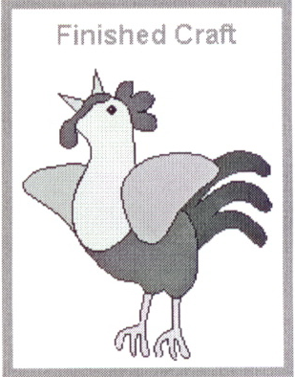Say: Each week this term we are going to make a puzzle piece. At the end of the term you will put the puzzle together and see what our stories this term are all about.

Craft:
- Hand out the puzzle piece
- Glue the rooster body pieces in place

Discuss the following depending on age, interest and time:
How do you feel when someone is mean to you?
How does Jesus feel when someone is mean to you? (Jesus said "You were doing it to Me")
How does Jesus feal when you are mean to someone else?
What different ways can people hurt other people? – Give physical, verbal and emotional examples.
Revise how Jesus told the disciples to pray last week: What might have been different for Peter if he had stayed awake to pray?
What do we need to do for God to forgive us? (Ask & forgive others)
1 John 1:9 "If we confess our sin…"
Matthew 6:12 "Forgive us our sins as we…"

Say: Jesus loved Peter, and even though He was sad and hurt by what Peter did Jesus forgave Peter. Jesus has promised to forgive us too. 1 John 1:9 says "But if we confess our sins to him, he is faithful and just to forgive us our sins."

Ask: What should we do when someone hurts us?

Say: When Jesus taught His disciples to pray He told them to say "Forgive us our sins, as we have forgiven those who sin against us" Matthew 6:12

Pray and ask God to forgive our sins and to help us forgive others

